1. Consider the linear programming problem of
Maximize 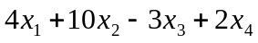
Subject to
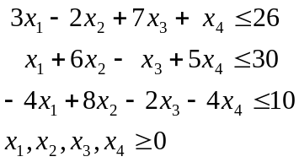
(a) Show that 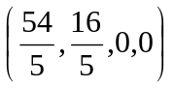is a feasible solution to this problem.
(b) Compute the value of the objective function at this point.
(c) Write out the dual problem.
(d) Show that 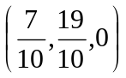is a feasible solution to this problem.
(e) What is the value of the objective function of the dual at this point?
(f) Using Corollary 4.4.2, what can you conclude?

2. Consider the linear programming problem of.
Maximize 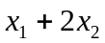
subject to
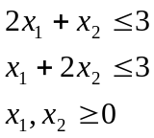
(a) Determine the dual problem;
(b) Show that 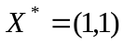and 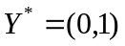are optimal solutions for the original and dual problems, respectively, by using the Complementary Slackness Theorem.
* Note that at these solution points, both 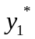and the slack in the corresponding first constraint of the max problem are zero.

3. Prove or disprove each of the following, using complementary slackness.
(a) (1,1,0,0) is an optimal solution point to the maximization problem of this problem:
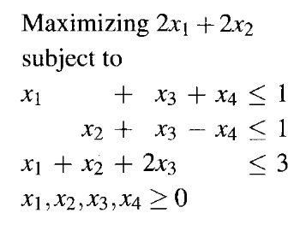

(b) (3,0,1,0,5) is an optimal solution point to the problem of:
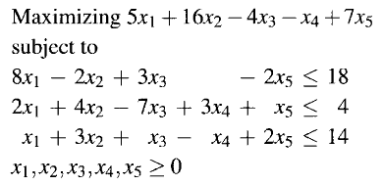

4. Consider the Example 1 of Chapter 5.3 (Lecture Notes Page 5-9).
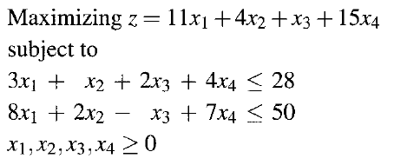
Suppose two changes are made in the coefficients of the objective function z: the coefficient of is increased from 11 to 13; and the coefficient of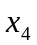is increased from 15 to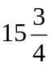. While each of these changes is within the corresponding allowable range for the coefficient as discussed in class:
- Show that (0,4,0,6) is no longer the optimal solution.
- Solve the modified problem.

5. Consider the linear programming problem of Example 2 of Chapter 5.2 (Lecture Notes Page 5-4).
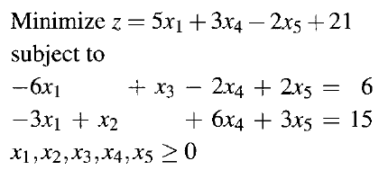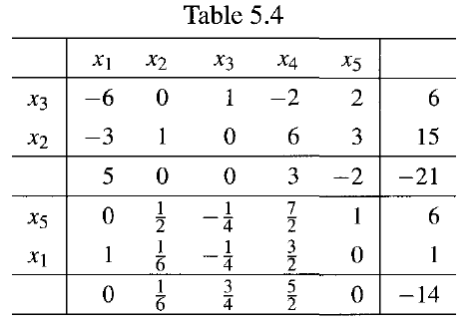
- Determine the range of each of the coefficients in objective function z such that if all the other coefficient of z remain fixed at the original value, the point (1,0,0,0,6) as determined from the second tableau of Table 5.4 remains an optimal solution point.
(b) Starting from the second tableau of Table 5.4, if in the objective function z, the coefficient of is increased to 9 and the coefficient of 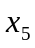is decreased to -3, solve the modified problem.

